***Lab Report # 07***

***Observing the temperature & pressure limit corresponding to specifically evaporator & condenser in heat pump***

* **Introduction:**

A Heat pump is a device that transfers heat energy from a source of heat to what is called a [thermal reservoir](https://en.wikipedia.org/wiki/Thermal_reservoir)

* **Principle:**

Its operating **principle** is based on compression and expansion of a working fluid, or so called 'refrigerant'. A **heat pump** has four main components: evaporator, compressor, condenser and expansion device. The refrigerant is the working fluid that passes through all these components.

* **Main Parts:**

 The most common design of a heat pump involves four main components;

* a [condenser](https://en.wikipedia.org/wiki/Condenser_(heat_transfer)),
* an [expansion valve](https://en.wikipedia.org/wiki/Thermal_expansion_valve),
* an [evaporator](https://en.wikipedia.org/wiki/Evaporator)
* a [compressor](https://en.wikipedia.org/wiki/Compressor).

The heat transfer medium circulated through these components is called [refrigerant](https://en.wikipedia.org/wiki/Refrigerant)

* **Diagram:**

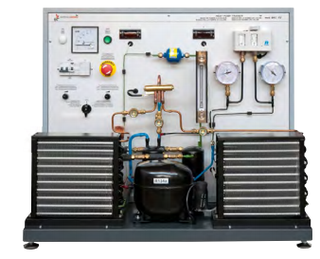

* **Working:**

Heat pumps move thermal energy in the opposite direction of spontaneous heat transfer, by absorbing heat from a cold space and releasing it to a warmer one. A heat pump uses external power to accomplish the work of transferring energy from the heat source to the heat sink.

* **Working of heat pump in winter:**

During the winter, heat pumps operate like an air conditioner in reverse. The refrigerant absorbs heat from the air outside and uses it to warm your home. ... In fact, most heat pumps can efficiently absorb heat from the air outside down to as cold as 20 degrees or lower!

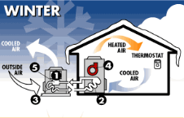

* **Working of heat pump in summer:**

During the summer, heat pumps work just like regular air conditioners. ... During the condensation process, the liquid refrigerant gives up its heat, which is radiated to the outside air. Now a cold, pressurized liquid, the refrigerant moves into the expansion valve, which restricts the flow of the liquid.

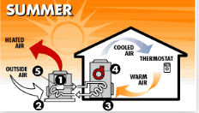

* **The Heating Cycle of Heat Pump:**

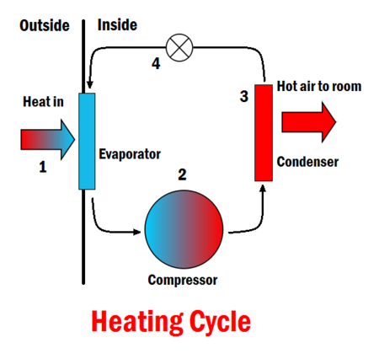 It works by taking **heat** in from air outside,warming it up further, and using this warm air to **heat** indoor air. It does so by the following process: Liquid refrigerant absorbs **heat** in the "evaporator" from the outdoor air, turning into a gas.

* **The Cooling Cycle of Heat Pump:**

It is used to cool a space by removing **heat** from it and expelling it to another area, usually to the outdoors for **air conditioning** or to the room for a refrigerator. ... The cold refrigerant absorbs **heat** from the hotter room in the evaporator, so the room will cool down.

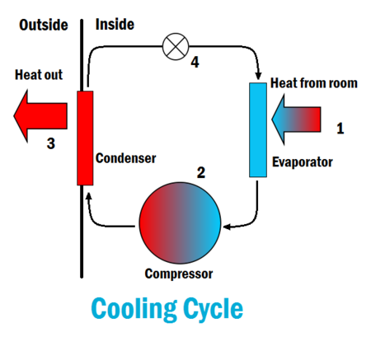

* **Application of Heat Pump:**

Following are the applications of heat pump;

* Domestic hot water ,space heating ,cooling for bungalows ,apartments, farm house and villas.
* Sanitary hot water for hotels, hospitals, leisure center.
* Commercial heating and cooling or buildings complexes.
* Constant hot water for swimming pool.
* Constant temperature for green house.
* High temperature heat pumps for drying and Steaming.
* **Relation of COP between Heat pump and Refrigerator:**

The COP of Refrigerator is given by the following equation:

COP = Desired Output/Required Input=Cooling Effect/Work Input = QL/Win.

The COP of a Heat pump is given by the following equation:

 COP = Desired Output/Required Input =Heating Effect/Work Input = QH/Win.

Both the COP of a refrigerator and a heat pump can be greater than one.

QL +Win=QH

Divide by Win on both sides:

QL/Win +Win/Win =QH/Win

COP (REF) +1=COP (HP)

Hence, COP of Heat Pump is Greater than COP of Refrigerator.

* **Calculations:**
* **For Summer Season:**

|  |  |
| --- | --- |
| **Part Name** | **Value** |
| Compressor Outlet | 34.2 |
| Condenser Inlet | 22.4 |
| Condenser Mid | 20.5 |
| Condenser Outlet | 20.7 |
| Expansion Valve | -8.0 |
| Liquid Receiver | 20.4 |
| Evaporator Inlet | -10.5 |
| Evaporator Mid | 18.2 |
| Evaporator Outlet | 17.6 |
| Compressor Inlet | 20.6 |

* **For Winter Season:**

|  |  |
| --- | --- |
| **Part Name** | **Value** |
| Condenser Mid | 23.6 |
| Condenser Inlet | 22.3 |
| Compressor Outlet | 24.7 |
| Condenser Outlet | 23.8 |
| Evaporator Inlet | -4.6 |
| Liquid Receiver | 23.0 |
| Evaporator Mid | 15.7 |
| Expansion Valve | -2.7 |
| Evaporator Outlet | 18.2 |
| Compressor Inlet | 16.6 |

* **Advantages:**
* Low running costs.
* Less maintenance.
* Safer than combustion-based system.
* Reduce your CO2 emissions.
* Provide cooling during summer.
* Long life span (+50 years), extremely reliable.
* Renewable Heat Incentive (RHI) scheme.